Lab#15
OPEN ENDED
OBJECTIVE: The objective of this program is to create a multiplayer Dice Rolling Race game in Java that demonstrates inheritance, multithreading, synchronization, generics, and exception handling. Each player runs on a separate thread, rolls dice simultaneously, and updates a shared total score safely using locks. The program also handles invalid inputs and errors gracefully, providing a practical and interactive way to learn and apply multiple Java concepts in a single application.
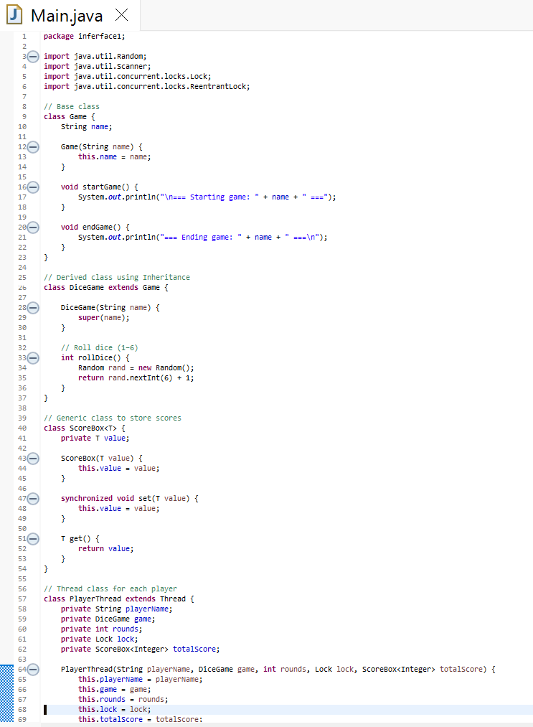
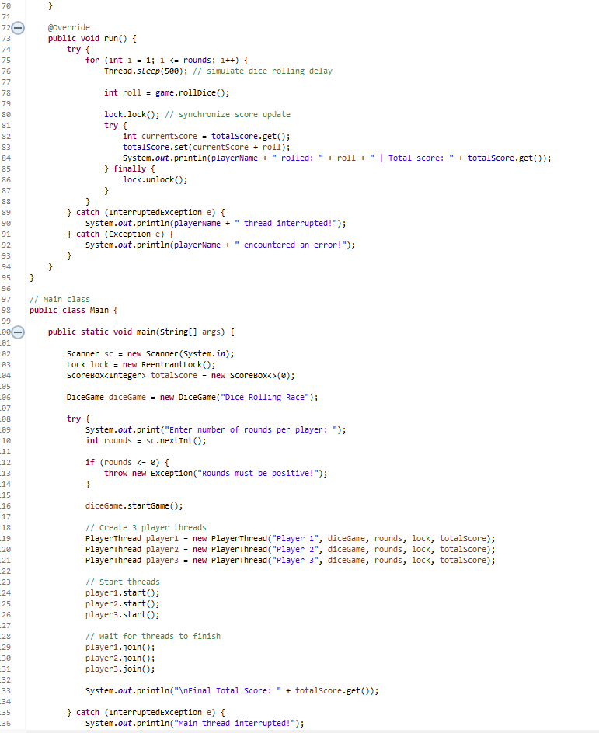
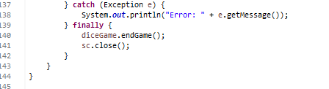
OUTPUT:
